**Recursive CTE**

A recursive CTE is like a loop in SQL.

It repeatedly runs a query until a condition is met.

It has 2 parts:

1. Anchor member-> starting point.
2. Recursive member-> query that keeps calling itself until the condition is false.

Syntax:

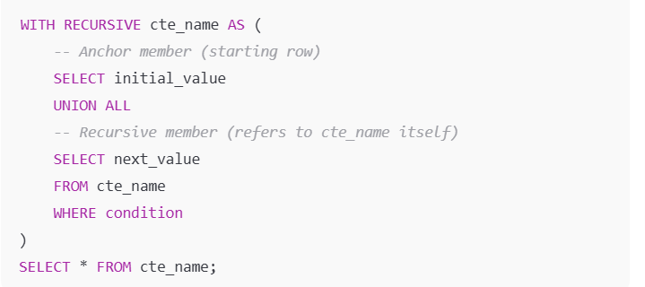

Example:

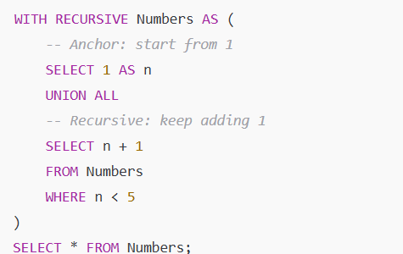

**Key Rules**

1. Must have **anchor + recursive part**.
2. Use UNION ALL (not UNION) otherwise duplicates removal slows things.
3. Must have a **stop condition** (otherwise infinite loop).
4. Good for:
   * Generating sequences (like numbers, dates).
   * Hierarchical data (employees, categories, file systems).

**Execution Flow**

1. **Anchor Part**
   * Runs **only once**.
   * Provides the **starting row(s)**.
2. **Recursive Part**
   * Runs repeatedly.
   * Each time, it takes the output of the **previous step** as input.
   * Keeps appending results.
3. **Stop Condition**
   * Defined in the WHERE clause (or join logic).
   * When condition fails → recursion stops.
4. **Final Result**
   * SQL engine combines anchor + all recursive results together.